From https://www.geeksforgeeks.org/machine-learning/random-forest-algorithm-in-machine-learning/
Random Forest Algorithm in Machine Learning
Last Updated : 2 May, 2026

Random Forest is a machine learning algorithm that uses many decision trees to make better predictions. Each tree looks at different random parts of the data and their results are combined by voting for classification or averaging for regression which makes it as ensemble learning technique. This helps in improving accuracy and reducing errors.
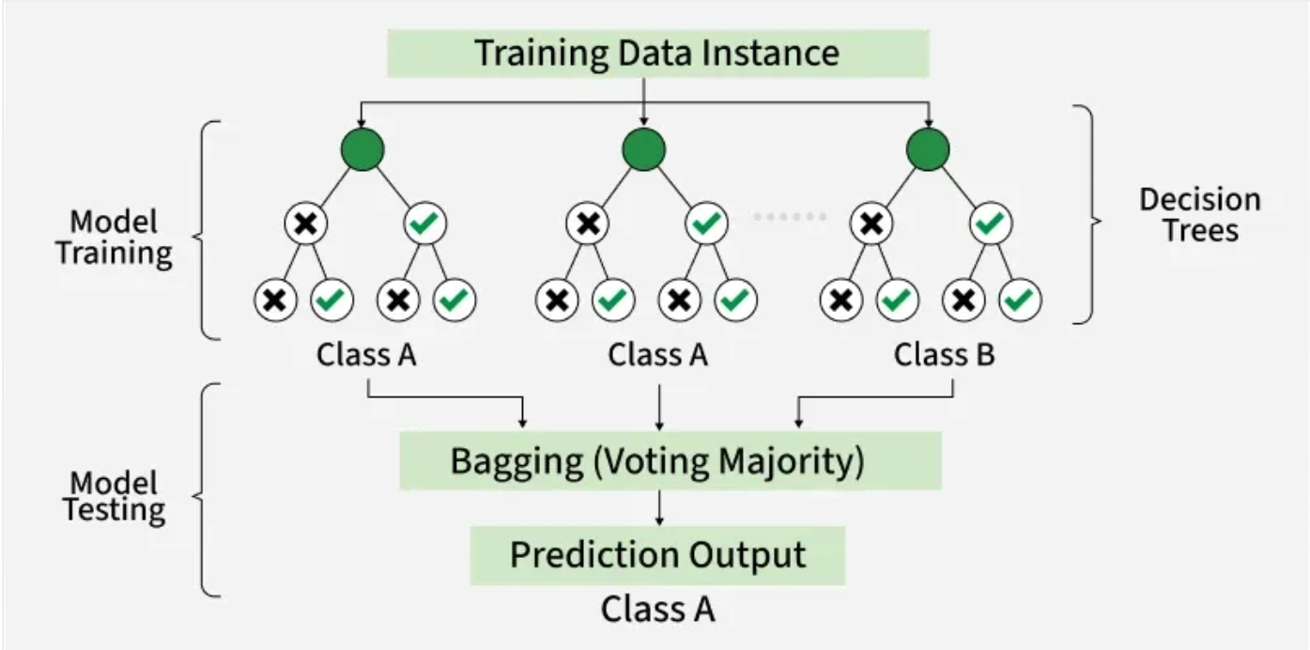
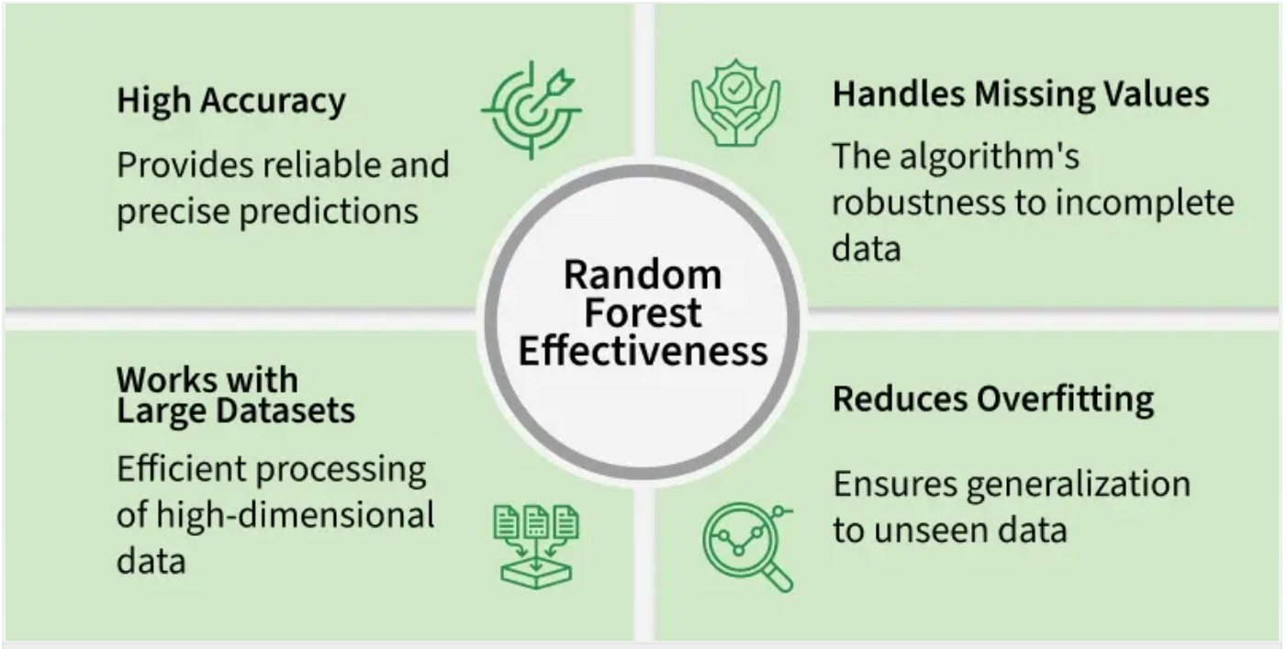
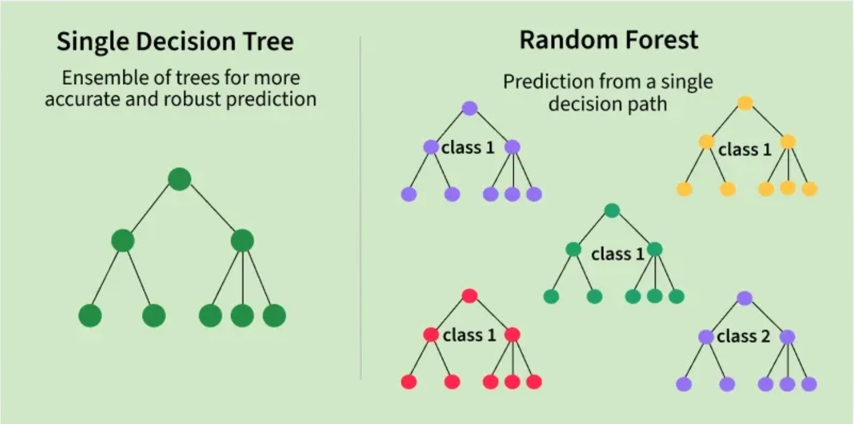
Working of Random Forest Algorithm
- Create Many Decision Trees: The algorithm makes many decision trees each using a random part of the data. So every tree is a bit different.
- Pick Random Features: When building each tree it doesn’t look at all the features (columns) at once. It picks a few at random to decide how to split the data. This helps the trees stay different from each other.
- Each Tree Makes a Prediction: Every tree gives its own answer or prediction based on what it learned from its part of the data.
- Combine the Predictions: For classification, the final answer is the category that most trees vote for (majority voting).
- Why It Works Well: Using random data and features for each tree helps avoid overfitting and makes the overall prediction more accurate and trustworthy.
Key Features of Random Forest
- Handles Missing Data: Works only after preprocessing , as most implementations like Scikit-learn do not support missing values directly.
- Shows Feature Importance: It tells you which features (columns) are most useful for making predictions which helps you understand your data better.
- Works Well with Big and Complex Data: It can handle large datasets with many features without slowing down or losing accuracy.
- Used for Different Tasks: You can use it for both classification like predicting types or labels and regression like predicting numbers or amounts.
Assumptions of Random Forest
- Each tree makes its own decisions: Every tree in the forest makes its own predictions without relying on others.
- Random parts of the data are used: Each tree is built using random samples and features to reduce mistakes.
- Enough data is needed: Sufficient data ensures the trees are different and learn unique patterns and variety.
- Different predictions improve accuracy: Combining the predictions from different trees leads to a more accurate final result.
Implementing Random Forest for Classification Tasks
Here we will predict survival rate of a person in titanic.
You can download dataset from here.
- Import libraries like pandas and scikit learn.
- Load the Titanic dataset.
- Remove rows with missing target values ('Survived').
- Select features like class, sex, age, etc and convert 'Sex' to numbers.
- Fill missing age values with the median.
- Split the data into training and testing sets, then train a Random Forest model.
- Predict on test data, check accuracy and print a sample prediction result.
import pandas as pd
from sklearn.model_selection import train_test_split
from sklearn.ensemble import RandomForestClassifier
from sklearn.metrics import accuracy_score, classification_report
import warnings
warnings.filterwarnings('ignore')

titanic_data = pd.read_csv('titanic.csv')

titanic_data = titanic_data.dropna(subset=['Survived'])

X = titanic_data[['Pclass', 'Sex', 'Age', 'SibSp', 'Parch', 'Fare']]
y = titanic_data['Survived']

X['Sex'] = X['Sex'].map({'female': 0, 'male': 1})
X['Age'] = X['Age'].fillna(X['Age'].median())

X_train, X_test, y_train, y_test = train_test_split(X, y, test_size=0.2, random_state=42)

rf_classifier = RandomForestClassifier(n_estimators=100, random_state=42)
rf_classifier.fit(X_train, y_train)

y_pred = rf_classifier.predict(X_test)

accuracy = accuracy_score(y_test, y_pred)
classification_rep = classification_report(y_test, y_pred)

print(f"Accuracy: {accuracy:.2f}")
print("\nClassification Report:\n", classification_rep)

sample = X_test.iloc[0:1]
prediction = rf_classifier.predict(sample)

sample_dict = sample.iloc[0].to_dict()
print(f"\nSample Passenger: {sample_dict}")
print(f"Predicted Survival: {'Survived' if prediction[0] == 1 else 'Did Not Survive'}")
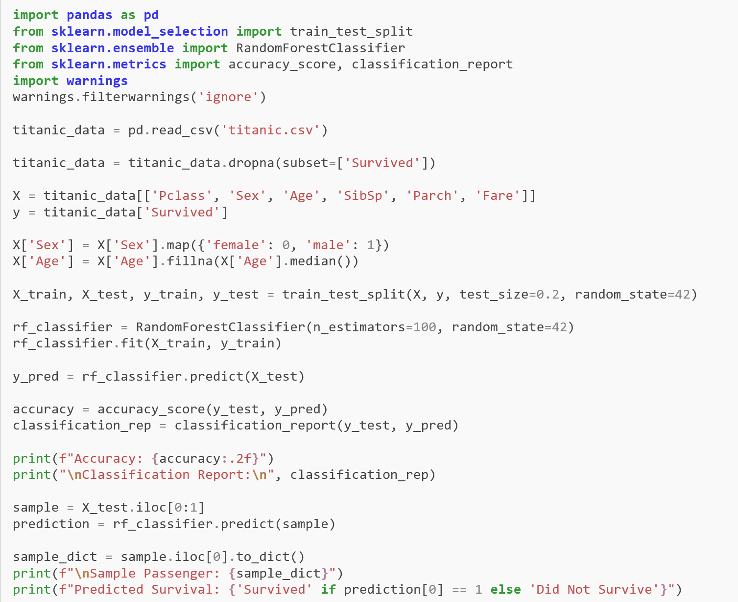

Output:
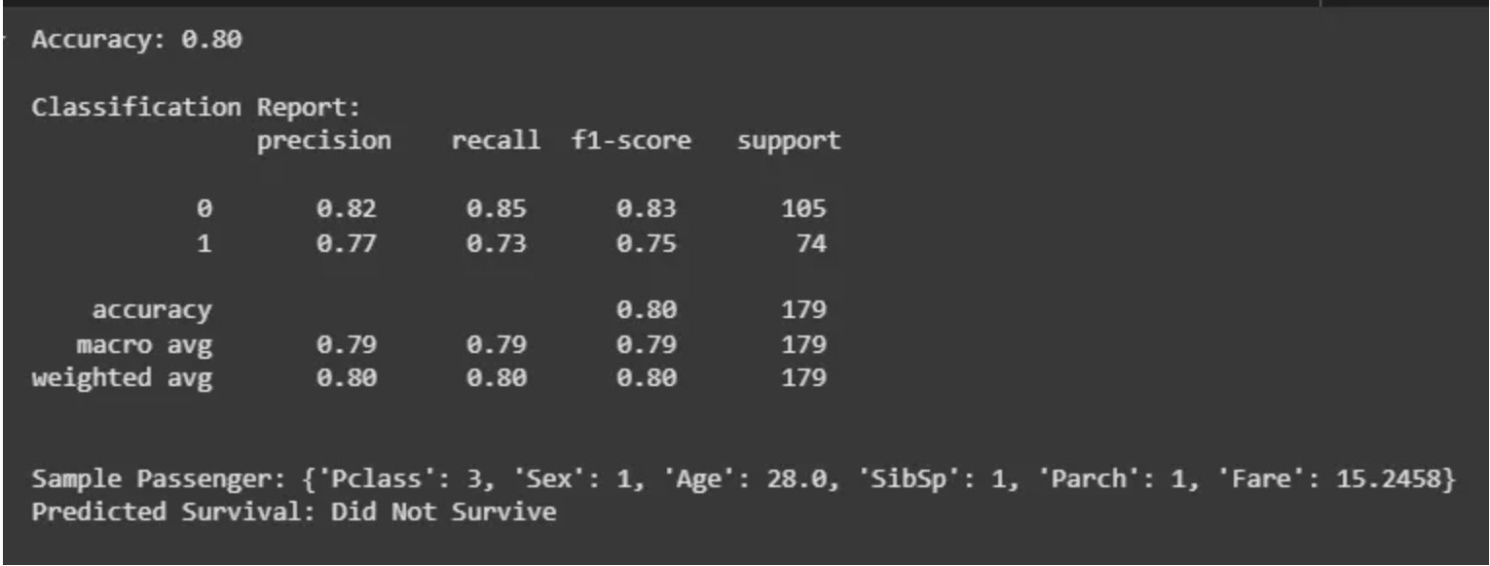
Random Forest for Classification Tasks
We evaluated model's performance using a classification report to see how well it predicts the outcomes and used a random sample to check model prediction.
Implementing Random Forest for Regression Tasks
We will do house price prediction here.
- Load the California housing dataset and create a DataFrame with features and target.
- Separate the features and the target variable.
- Split the data into training and testing sets (80% train, 20% test).
- Initialize and train a Random Forest Regressor using the training data.
- Predict house values on test data and evaluate using MSE and R² score.
- Print a sample prediction and compare it with the actual value.
import pandas as pd
from sklearn.datasets import fetch_california_housing
from sklearn.model_selection import train_test_split
from sklearn.ensemble import RandomForestRegressor
from sklearn.metrics import mean_squared_error, r2_score

california_housing = fetch_california_housing()
california_data = pd.DataFrame(california_housing.data, columns=california_housing.feature_names)
california_data['MEDV'] = california_housing.target

X = california_data.drop('MEDV', axis=1)
y = california_data['MEDV']

X_train, X_test, y_train, y_test = train_test_split(X, y, test_size=0.2, random_state=42)

rf_regressor = RandomForestRegressor(n_estimators=100, random_state=42)

rf_regressor.fit(X_train, y_train)

y_pred = rf_regressor.predict(X_test)

mse = mean_squared_error(y_test, y_pred)
r2 = r2_score(y_test, y_pred)

single_data = X_test.iloc[0].values.reshape(1, -1)
predicted_value = rf_regressor.predict(single_data)
print(f"Predicted Value: {predicted_value[0]:.2f}")
print(f"Actual Value: {y_test.iloc[0]:.2f}")

print(f"Mean Squared Error: {mse:.2f}")
print(f"R-squared Score: {r2:.2f}")
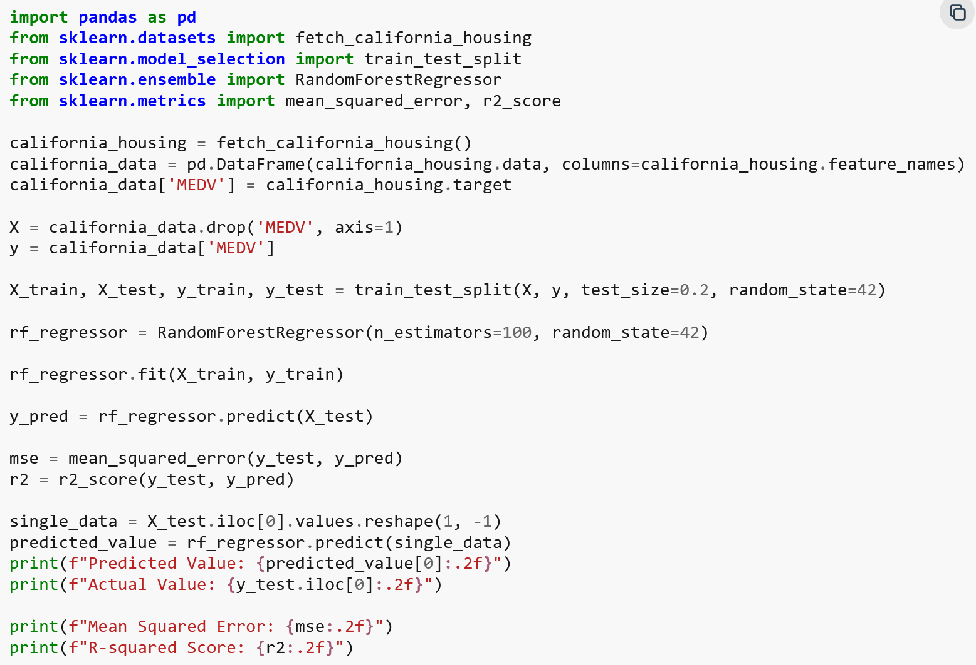
Output:
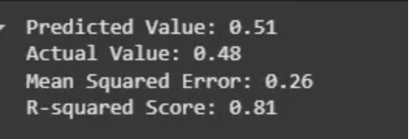
Random Forest for Regression Tasks
We evaluated the model's performance using Mean Squared Error and R-squared Score which show how accurate the predictions are and used a random sample to check model prediction.
Advantages
- Random Forest provides very accurate predictions even with large datasets.
- Random Forest can perform well after handling missing data through preprocessing techniques like imputation.
- It doesn’t require normalization or standardization on dataset.
- When we combine multiple decision trees it reduces the risk of overfitting of the model.
Limitations
- It can be computationally expensive especially with a large number of trees.
- It’s harder to interpret the model compared to simpler models like decision trees.
Related Article
- Ensemble Learning
Random Forest Algorithm in Machine Learning
Visit Course
Suggested Quiz
What is the main advantage of using the Random Forest algorithm?
- A
It always gives 100% accuracy
- B
It reduces overfitting and improves generalization
- C
It requires only one decision tree for better performance
- D
It works only for classification problems
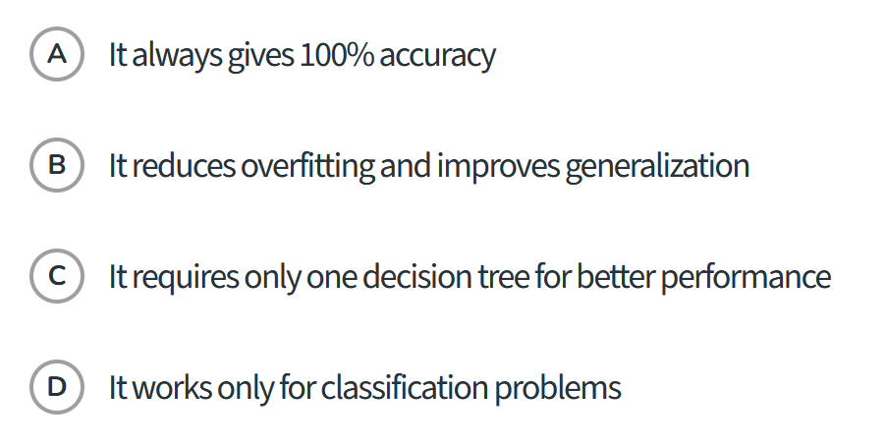

What is bagging in Machine Learning?

Bagging (short for bootstrap aggregating) is an ensemble machine learning technique designed to improve the stability and accuracy of predictive models by reducing variance and preventing overfitting. [1, 2, 3]
How Bagging Works
Bagging operates through two primary steps: bootstrapping and aggregation. [1, 2]
- Bootstrap Sampling (Row Sampling):
  - The algorithm creates multiple random subsets of the original training dataset by sampling with replacement.
  - "With replacement" means a specific data point can be selected multiple times in one subset, or left out completely. [1, 2, 3]
- Parallel Model Training:
  - An independent base model (such as a decision tree, support vector machine, or neural network) is trained on each bootstrap subset.
  - Because all models are trained simultaneously and independently in parallel, the process is computationally efficient. [1, 2, 3, 4]
- Aggregation (Combining Predictions):
  - When new data comes in, the individual models make predictions.
  - For Classification: The final output is decided by majority voting (the class chosen by the most models).
  - For Regression: The final output is calculated by averaging the predictions of all the base models. [1, 2, 3]

Why Bagging Is Used
- Reduces Variance: Individual models like deep, unpruned decision trees have high variance—meaning small changes in the training data lead to completely different trees. Averaging or voting across multiple diverse trees cancels out these individual errors.
- Resists Overfitting: Training on randomized subsets gives each model a different "view" of the data, improving generalization to unseen data.
- Handles Noise Well: Unlike boosting, bagging is generally less sensitive to noisy data and outliers. [1, 2, 3, 4, 5]

Key Examples and Algorithms
- Random Forest: The most famous extension of bagging. It builds an ensemble of decision trees, and at every split within the trees, it also uses random feature subsetting (random subspacing) to make the trees even more diverse.
- Scikit-Learn Implementation: In Python, you can use built-in tools like BaggingClassifier, BaggingRegressor, or RandomForestClassifier from scikit-learn. [1, 2, 3, 4, 5, 6]

Bagging vs. Boosting
Feature | Bagging | Boosting
Primary Goal | Reduce variance | Reduce bias
Training Style | Independent (parallel) | Sequential (one after another)
Error Handling | Treats all samples equally | Focuses heavily on misclassified samples
Base Learners | High-variance models (e.g., deep decision trees) | Weak learners that improve over time
Overfitting Risk | Less sensitive to overfitting | More prone to overfitting if unchecked
For a broader overview of ensemble strategies, check out the guide on Bagging vs Boosting in Machine Learning. [1]

What is boosting in Machine Learning?

Boosting is a sequential ensemble machine learning technique that converts a series of weak learners (simple models that perform only slightly better than random guessing) into a single, high-accuracy strong learner. [1, 2]
Unlike bagging—which trains models independently and in parallel—boosting trains models one after another. Each new model specifically focuses on correcting the errors or residuals made by its predecessor. [1, 2, 3, 4, 5]

How Boosting Works
- Initial Model: An initial base model (often a shallow decision tree) is trained on the dataset.
- Error Evaluation: The algorithm evaluates the predictions and identifies which data points were misclassified or have high errors.
- Sequential Correction: The next model is trained with an emphasis on those difficult cases—either by re-weighting the data samples (as in AdaBoost) or by fitting the new model directly to the prediction errors/residuals (as in Gradient Boosting).
- Aggregation: The predictions of all weak learners are combined (via weighted voting or weighted averaging) to form the final output. [1, 2, 3, 4, 5]

Common Boosting Algorithms
- AdaBoost (Adaptive Boosting): Adjusts the weights of misclassified data points after each round so subsequent weak classifiers focus harder on difficult-to-classify samples. [1, 2]
- Gradient Boosting (GBRT): Formulates the boosting process as a gradient descent optimization problem, where each new tree is trained to predict the negative gradients (residuals) of the loss function. [1, 2]
- XGBoost (Extreme Gradient Boosting): An optimized, scalable implementation of gradient boosting that incorporates regularization, tree pruning, and parallelized computation for speed and performance. [1, 2]
- CatBoost & LightGBM: Advanced, high-speed gradient boosting frameworks tailored for handling categorical variables and massive datasets efficiently.

Key Pros and Cons
- Pros:
  - Greatly reduces bias and improves predictive accuracy.
  - Handles a variety of data types well and excels on structured/tabular data competitions. [1, 2, 3, 4]
- Cons:
  - Prone to overfitting if the number of estimators or tree depth is set too high.
  - Slower to train than parallelized methods (like Random Forest) because models must be built sequentially.
  - Sensitive to noisy data and outliers, which can skew the re-weighting process. [1, 2, 3]
Read a detailed overview on Wikipedia: Boosting (machine learning). [1]

